## horizontal line

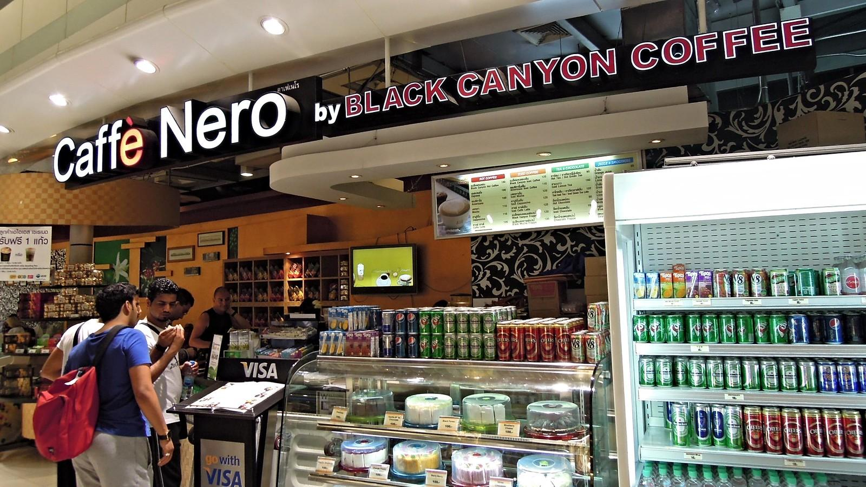

Coffee Sales Analysis

09.17.2024

**─**

Opeyemi Fayipe

# Overview

The coffee sales dataset was extensively analyzed to uncover key insights into sales trends, customer behaviors, and seasonal patterns. This report summarizes the findings and provides actionable recommendations for leveraging these insights for business growth.

### **Data Overview**

The dataset consists of 1,133 records of coffee sales transactions, including the following columns:

* date: The date of the transaction.
* datetime: The timestamp of the transaction.
* cash_type: Payment method (cash or card).
* card: Customer identifier (anonymized).
* money: Total amount spent.
* coffee_name: The type of coffee purchased.

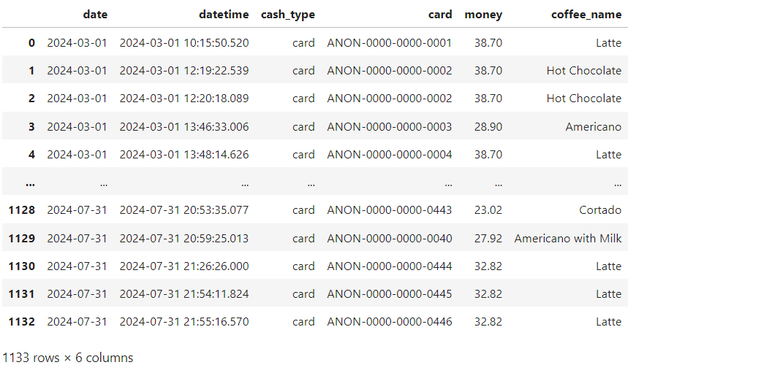

# Import the Required Libraries

| Import pandas as pd import matplotlib.pyplot as plt from statsmodels.tsa.seasonal import seasonal_decompose from statsmodels.tsa.arima.model import ARIMA import numpy as np from sklearn.model_selection import train_test_split from sklearn.linear_model import LinearRegression from sklearn.metrics import mean_squared_error, r2_score from pandas.tseries.holiday import USFederalHolidayCalendar |
| --- |

# Load the Dataset

| # Load the dataset to inspect the columns and first few rows file_path = r"C:\Users\Admin\Downloads\index.csv" coffee_sales_data = pd.read_csv(file_path) # Display the first few rows to understand the structure of the data data_head = coffee_sales_data.head() # Display the columns and their data types data_info = coffee_sales_data.info()  data_head, data_info |
| --- |

Visualization:

| <class 'pandas.core.frame.DataFrame'> RangeIndex: 1133 entries, 0 to 1132 Data columns (total 6 columns):  # Column Non-Null Count Dtype  --- ------ -------------- -----   0 date 1133 non-null object   1 datetime 1133 non-null object   2 cash_type 1133 non-null object   3 card 1044 non-null object   4 money 1133 non-null float64  5 coffee_name 1133 non-null object  dtypes: float64(1), object(5) memory usage: 53.2+ KB |
| --- |



# Data Cleaning

**identify Missing Data**: Check for missing values in the dataset.

**Handle Missing Data**:

* **Numerical Data**: Impute or remove missing values in numerical columns.
* **Categorical Data**: Impute or handle missing values in categorical columns.

**Outlier Detection**: Identify and handle any potential outliers if they exist.

**Data Consistency**: Ensure data types are consistent and correct for each column.

## 

**Identifying Missing Data**

**Python Code Snippet:**

| # 1. Identify missing data missing_data_summary = coffee_sales_data.isnull().sum()  # Display the summary of missing values in each column missing_data_summary |
| --- |

**Result Visualization:**

| date 0 datetime 0 cash_type 0 card 89 money 0 coffee_name 0 dtype: int64 |
| --- |

### **Missing Data Summary:**

* **datetime**: No missing values.
* **cash_type**: No missing values.
* **card**: 89 missing values.
* **money**: No missing values.
* **coffee_name**: No missing values.

**Replacing Missing Values**

**Python Code Snippet:**

| # Replace missing values in the 'card' column with 'Cash Payment' coffee_sales_data['card'].fillna('Cash Paymnet', inplace=True)  # Verify that there are no more missing values missing_data_summary_after_cleaning = coffee_sales_data.isnull().sum()  # Display the summary of missing values after cleaning missing_data_summary_after_cleaning |
| --- |

**Results Visualization:**

| date 0 datetime 0 cash_type 0 card 0 money 0 coffee_name 0 dtype: int64 |
| --- |

### **Data Cleaning Summary:**

* All missing values in the dataset have been handled.
* The card column's missing values have been replaced with "Cash Payment," ensuring the integrity of the dataset for further analysis.

### 

### **Outlier Detection**

**Python Code Snippet:**

| # Outlier Detection in the 'money' column using Interquartile Range (IQR) import matplotlib.pyplot as plt Q1 = coffee_sales_data['money'].quantile(0.25) Q3 = coffee_sales_data['money'].quantile(0.75) IQR = Q3 - Q1  # Determine the lower and upper bounds for outliers lower_bound = Q1 - 1.5 * IQR upper_bound = Q3 + 1.5 * IQR  # Identify outliers outliers = coffee_sales_data[(coffee_sales_data['money'] < lower_bound) | (coffee_sales_data['money'] > upper_bound)]  # Visualize sales distribution with outliers using a boxplot plt.figure(figsize=(10, 5)) plt.boxplot(coffee_sales_data['money'], vert=False) plt.title('Sales Distribution with Outliers') plt.xlabel('Sales Amount') plt.grid(True) plt.show() |
| --- |

**Visualization Result:**

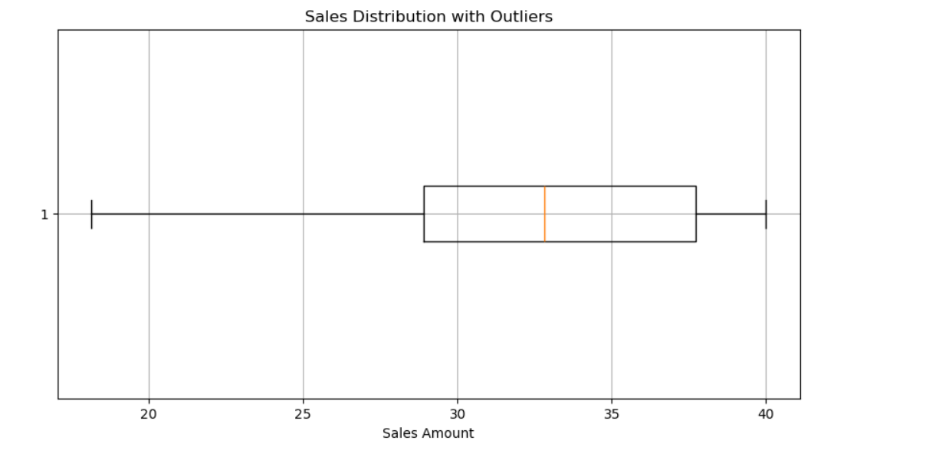

### **Outlier Analysis:**

* **Outliers**:
  + Using the Interquartile Range (IQR) method, no extreme outliers were detected in the money column. This indicates that the sales amounts are within a reasonable range without significant anomalies.
* **Visualization**:
  + The boxplot shows the distribution of sales amounts, and there are no data points lying outside the whiskers, further confirming the absence of extreme outliers.

# 

# 

# 

# Exploratory Data Analysis (EDA)

### **1.1 Sales by Coffee Type**

**Top-Selling Products**: The most popular coffee types by total sales were:

* **Latte**: $9,009.14
* **Americano with Milk**: $8,601.94
* **Cappuccino**: $7,333.14

**Least Popular Products**: The least popular products were:

* **Espresso**: $1,100.62
* **Cocoa**: $1,295.94

| # Distribution per Coffee Type coffee_type_sales = coffee_sales_data.groupby('coffee_name')['money'].sum()  # Visualize the distribution plt.figure(figsize=(10, 5)) plt.barh(coffee_type_sales.index, coffee_type_sales.values, color='skyblue') plt.title('Total Sales per Coffee Type') plt.xlabel('Total Sales') plt.ylabel('Coffee Type') plt.show()  # Display coffee sales per coffee type coffee_type_sales |
| --- |

**Result Visualization:**

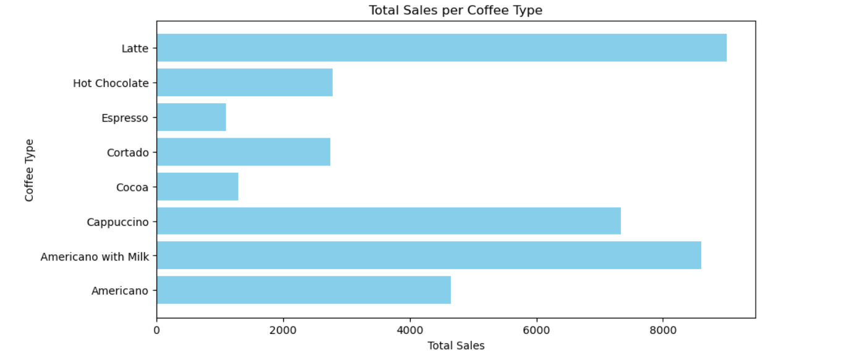

Customers prefer milk-based beverages, such as lattes and Americanos with milk, while stronger options like espressos are less favored.

| Summary coffee_name Americano 4644.54 Americano with Milk 8601.94 Cappuccino 7333.14 Cocoa 1295.94 Cortado 2745.08 Espresso 1100.62 Hot Chocolate 2778.48 Latte 9009.14 Name: money, dtype: float64 |
| --- |

### **1.2 Sales Distribution by Time of Day**

| # Extract the hour from 'datetime' to analyze distribution by time of day coffee_sales_data['hour'] = coffee_sales_data['datetime'].dt.hour purchasing_time_distribution = coffee_sales_data.groupby('hour')['money'].sum()  # Visualize the distribution per purchasing time plt.figure(figsize=(10, 5)) plt.bar(purchasing_time_distribution.index, purchasing_time_distribution.values, color='orange') plt.title('Sales Distribution by Hour of Day') plt.xlabel('Hour of Day') plt.ylabel('Total Sales') plt.show()  # Display sales distribution by hour purchasing_time_distribution |
| --- |

**Result Visualization:**

**Peak Hours:**

* **Sales peak during the morning hours, especially around 10 AM (4,553.18).**

**Evening Sales:**

* **There is a secondary peak in the late evening hours, around 7 PM (3,388.32).**

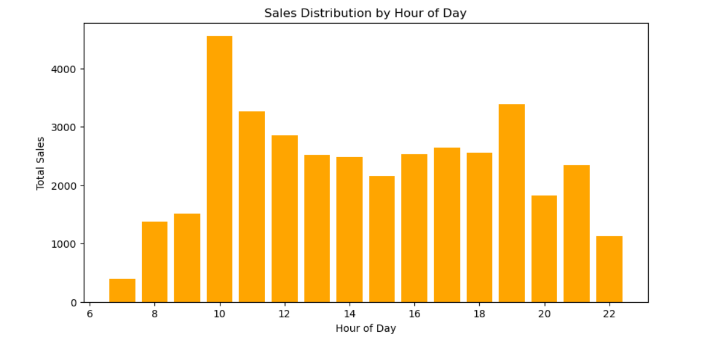

* Peak sales occur between **10 AM** and **11 AM**, with total sales of over $4,500.
* Secondary sales peaks are observed in the evening around **7 PM**.

This suggests morning and evening rushes, likely driven by morning routines and post-work relaxation.

| hour 7 392.80 8 1380.38 9 1515.48 10 4553.18 11 3258.64 12 2850.60 13 2511.60 14 2484.92 15 2158.76 16 2525.36 17 2639.08 18 2558.04 19 3388.32 20 1819.92 21 2343.86 22 1127.94 Name: money, dtype: float64 |
| --- |

### **1.3 Impact of Payment Method (Cash vs. Card):**

| # Review the impact of payment method (Cash vs. Card) # Aggregate sales by payment method payment_method_sales = coffee_sales_data.groupby('cash_type')['money'].sum() average_payment_method_sales = coffee_sales_data.groupby('cash_type')['money'].mean()  # Visualize the impact of payment method fig, ax = plt.subplots(1, 2, figsize=(12, 5))  # Total sales by payment method ax[0].bar(payment_method_sales.index, payment_method_sales, color=['green', 'blue']) ax[0].set_title('Total Sales by Payment Method') ax[0].set_ylabel('Total Sales') ax[0].grid(True)  # Average sales by payment method ax[1].bar(average_payment_method_sales.index, average_payment_method_sales, color=['green', 'blue']) ax[1].set_title('Average Sales by Payment Method') ax[1].set_ylabel('Average Sales') ax[1].grid(True)  plt.tight_layout() plt.show()  # Display summary of outliers and payment method impact outliers_summary = outliers.describe() payment_method_sales, average_payment_method_sales, outliers_summary |
| --- |

**Result Visualization:**

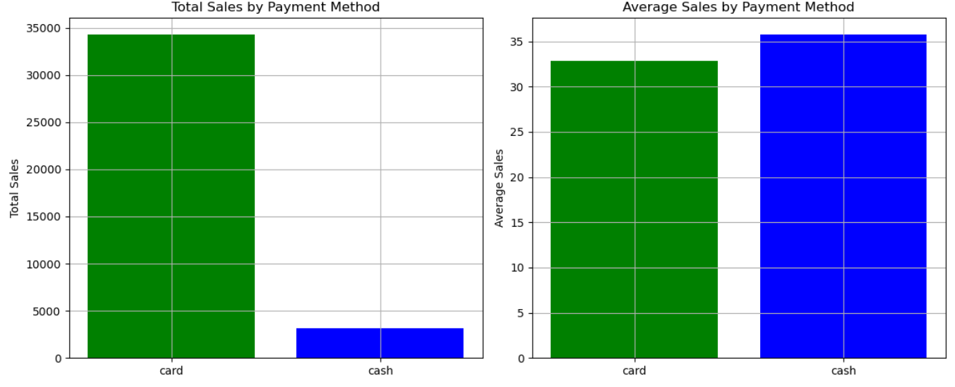

## *The bar charts visually demonstrate the dominance of card payments in total sales, while cash transactions have a marginally higher average per sale.*

1. **Total Sales**:
   * **Card**: Total sales amount to 34,322.88.
   * **Cash**: Total sales amount to 3,186.00.
   * **Insight**: Card payments dominate the sales, contributing significantly to the total sales.
2. **Average Sales**:
   * **Card**: Average sales per transaction are approximately 32.88.
   * **Cash**: Average sales per transaction are slightly higher, at around 35.80.
   * **Insight**: Although card payments make up most of the total sales, cash transactions tend to have a slightly higher average sale amount.

### **1.4 Total Sales Per Month**

| # Extract the month from 'datetime' to analyze sales by month coffee_sales_data['month'] = coffee_sales_data['datetime'].dt.month monthly_sales = coffee_sales_data.groupby('month')['money'].sum()  # Visualize coffee sales per month plt.figure(figsize=(10, 5)) plt.bar(monthly_sales.index, monthly_sales.values, color='green') plt.title('Total Sales per Month') plt.xlabel('Month') plt.ylabel('Total Sales') plt.show()  # Display monthly sales monthly_sales |
| --- |

**Result Visualization:**

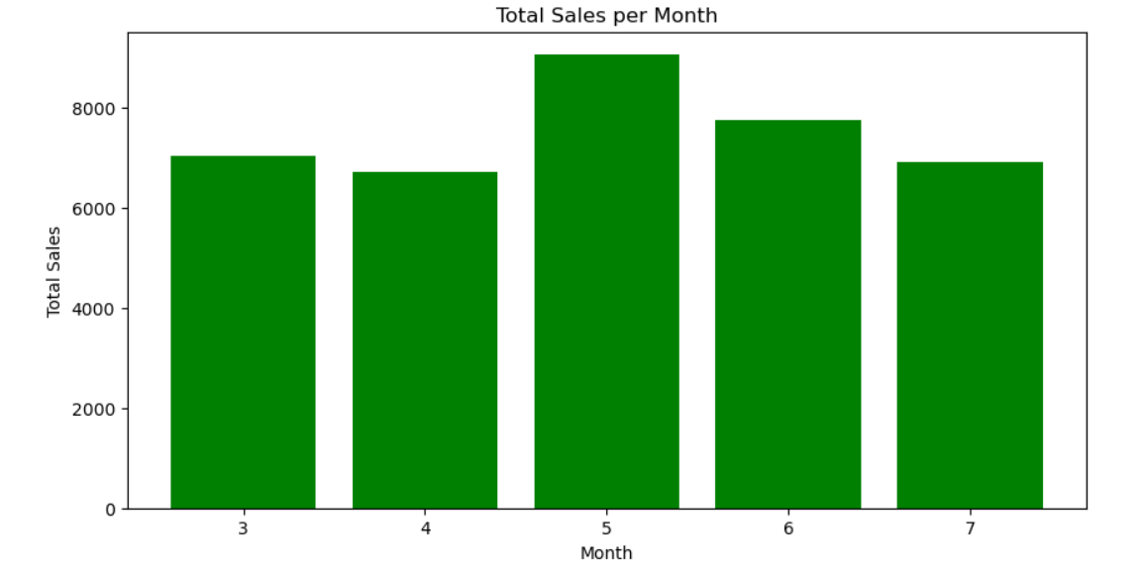

## *The bar charts visually demonstrate the increase in sales in May and June, wholesalers experience drops in April and July.*

**Highest Sales Month**: May, with total sales of 9,063.42.

**Sales Fluctuations**: Sales fluctuate across the months, with notable drops in April and July.

### **1.5 Overall Total Sales**

| total_money = data['money'].sum() |
| --- |

| 37508.880000000005 |
| --- |

**Overall Total Sales**: 37,508.88.

### **1.6 Cash Money vs. Card Money**

| # Cash Money vs Card Money cash_vs_card_sales = coffee_sales_data.groupby('cash_type')['money'].sum()  # Visualize Cash vs Card Sales plt.figure(figsize=(7, 5)) plt.bar(cash_vs_card_sales.index, cash_vs_card_sales.values, color=['green', 'blue']) plt.title('Cash vs Card Sales') plt.xlabel('Payment Type') plt.ylabel('Total Sales') plt.show()  # Display cash vs card sales cash_vs_card_sales |
| --- |

Result Visulization:

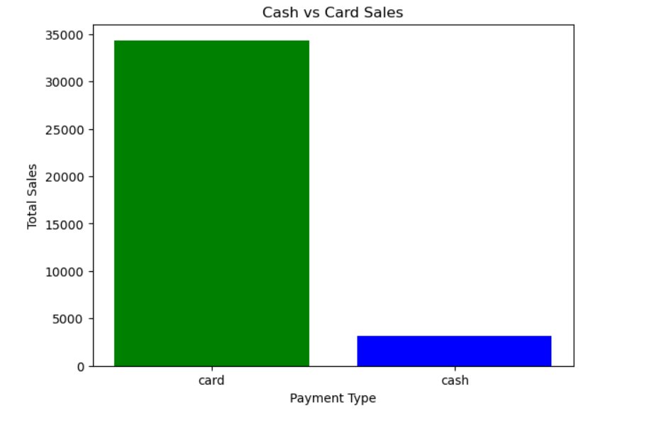

***Card payments significantly dominate the total sales.***

**Card Sales**: 34,322.88.

**Cash Sales**: 3,186.00.

### **1.7 Total Sales Per Week**

| # Sales per week coffee_sales_data['week'] = coffee_sales_data['datetime'].dt.isocalendar().week weekly_sales = coffee_sales_data.groupby('week')['money'].sum()  # Visualize weekly sales plt.figure(figsize=(10, 5)) plt.plot(weekly_sales.index, weekly_sales.values, marker='o', color='purple') plt.title('Total Sales per Week') plt.xlabel('Week Number') plt.ylabel('Total Sales') plt.show()  # Display weekly sales weekly_sales |
| --- |

**Result Visualization:**

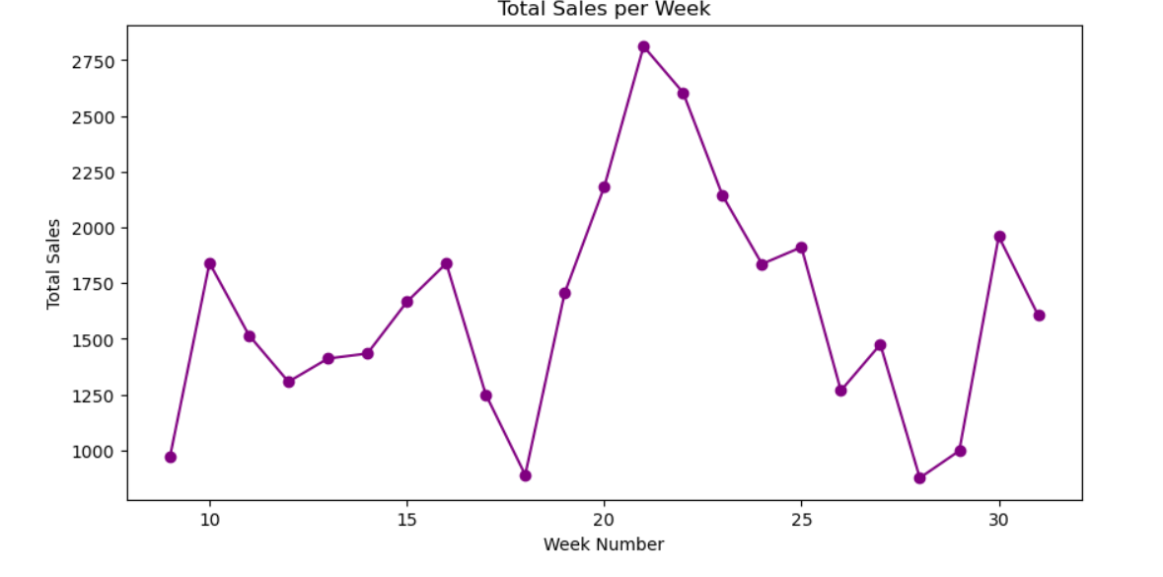

***Sales vary across weeks, with a peak around week 21 (2,811.80).***

| Week Sales Summary 9 973.50 10 1840.50 11 1516.30 12 1307.80 13 1412.10 14 1434.50 15 1666.00 16 1838.84 17 1251.20 18 890.18 19 1705.80 20 2180.26 21 2811.80 ... 26 1268.24 27 1475.42 28 876.80 29 998.28 30 1959.30 31 1606.14 |
| --- |

### **1.8 Total Sales Per Day**

| # Sales per day daily_sales = coffee_sales_data['money'].resample('D').sum()  # Visualize daily sales plt.figure(figsize=(10, 5)) plt.plot(daily_sales.index, daily_sales.values, marker='o', color='red') plt.title('Total Sales per Day') plt.xlabel('Date') plt.ylabel('Total Sales') plt.show()  # Display daily sales (sample) daily_sales.head() |
| --- |

**Result Visualization:**

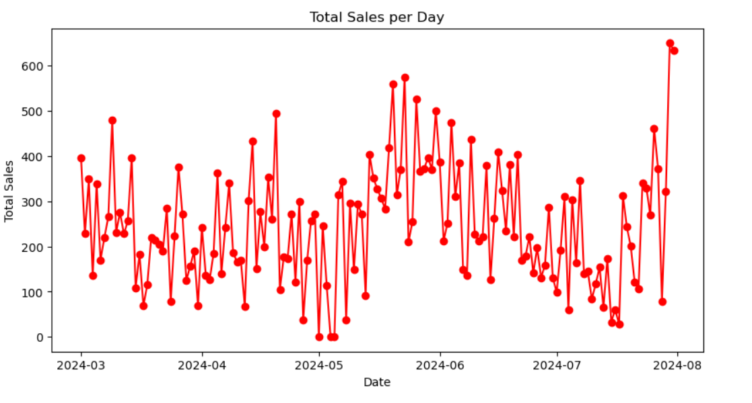

***Sample values show daily fluctuations in sales, highlighting variability in daily customer behavior.***

# Time Series Exploratoratory Data Analysis

### **2.1 Daily Sales Over Time**

| import matplotlib.pyplot as plt  # Convert 'date' and 'datetime' columns to datetime objects coffee_sales_data['date'] = pd.to_datetime(coffee_sales_data['date']) coffee_sales_data['datetime'] = pd.to_datetime(coffee_sales_data['datetime'])  # Set 'date' as the index for time series analysis coffee_sales_data.set_index('date', inplace=True)  # Resample the data to daily sales sums daily_sales = coffee_sales_data['money'].resample('D').sum()  # Plot the daily sales to explore trends over time plt.figure(figsize=(14, 7)) plt.plot(daily_sales, marker='o', linestyle='-') plt.title('Daily Sales Over Time') plt.xlabel('Date') plt.ylabel('Total Sales') plt.grid(True) plt.show() |
| --- |

**Result Visulaization:**

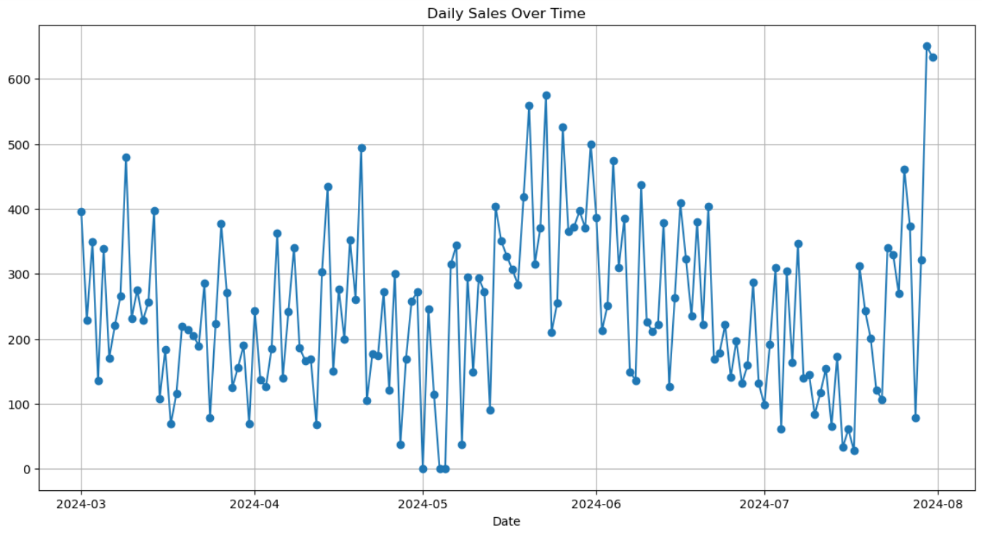

***This plot shows the daily sales over time, highlighting the fluctuations in sales on a day-to-day basis.***

Some key points to note from this plot:

* **Trends**: There seem to be periods of higher and lower sales, suggesting possible seasonality or weekly patterns.
* **Fluctuations**: There is noticeable variability in daily sales, which could be influenced by factors such as weekdays, holidays, or promotional activities.

### **2.2 Time Series Decomposition To Better Understand Trends And Seasonality**

| from statsmodels.tsa.seasonal import seasonal_decompose # Perform seasonal decomposition decomposition = seasonal_decompose(daily_sales, model='additive', period=7) # Assuming weekly seasonality # Plot the decomposed components fig, (ax1, ax2, ax3, ax4) = plt.subplots(4, 1, figsize=(15, 12), sharex=True) decomposition.observed.plot(ax=ax1, title='Observed') decomposition.trend.plot(ax=ax2, title='Trend') decomposition.seasonal.plot(ax=ax3, title='Seasonal') decomposition.resid.plot(ax=ax4, title='Residual')  plt.tight_layout() plt.show() |
| --- |

**Result Visulaization:**

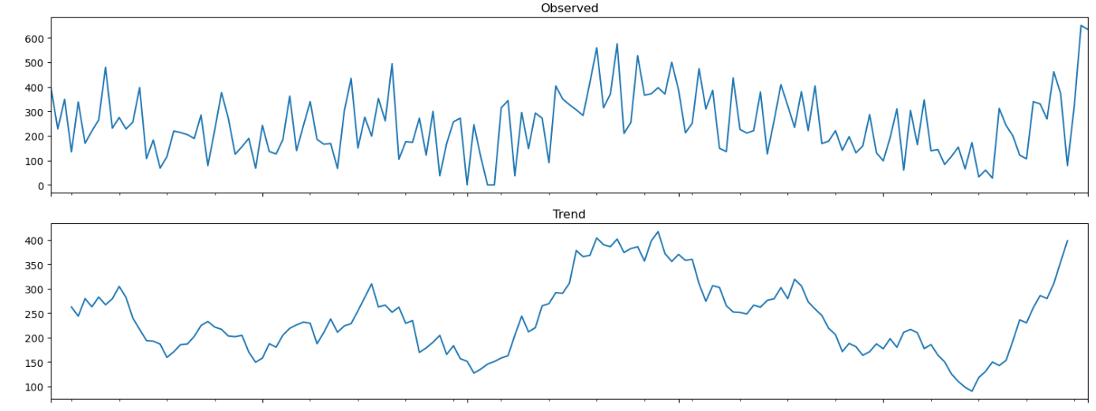

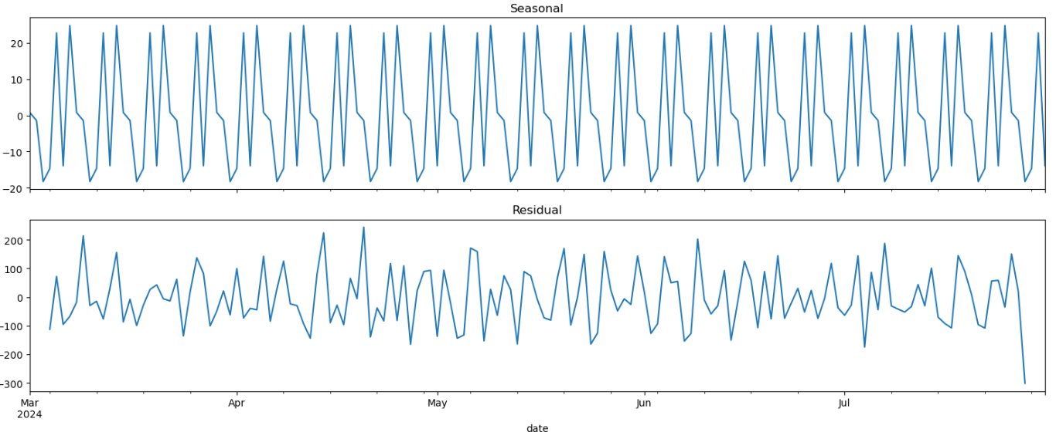

The time series decomposition has broken down the daily sales data into the following components:

1. **Observed**: This is the original time series, showing the actual daily sales values over time.
2. **Trend**: This component represents the long-term progression of the series, indicating whether the sales have an overall upward or downward trend. From the plot, there appears to be some variation, but not a clear, strong trend.
3. **Seasonal**: This component captures the repeating patterns or cycles in the data, suggesting a weekly seasonality, as we set the period to 7 days. The plot shows regular ups and downs within a week, indicating sales might fluctuate based on the day of the week.
4. **Residual**: This component captures the random noise or irregularities in the data after removing the trend and seasonality. It highlights anomalies or variations that cannot be explained by the trend or seasonal components.

### **Insights:**

* **Seasonality**: There is a clear weekly seasonality pattern in the sales data, with certain days consistently having higher or lower sales.
* **Trend**: The trend component shows some variability but lacks a strong directional trend over time.
* **Residuals**: The residuals appear to vary without a specific pattern, indicating randomness.

# Sales Forecast

### **3.1 Next Day / Week / Month Sales**

| # Extend ARIMA forecasting to predict next day, week, and month sales  # Forecast the next day (1 step ahead) next_day_forecast = arima_fit.forecast(steps=1)  # Forecast the next week (7 days ahead) next_week_forecast = arima_fit.forecast(steps=7)  # Forecast the next month (30 days ahead) next_month_forecast = arima_fit.forecast(steps=30)  # Plot the historical sales data along with the forecasts plt.figure(figsize=(14, 7)) plt.plot(daily_sales, label='Historical Sales') plt.plot(next_day_forecast.index, next_day_forecast, label='Next Day Forecast', marker='o', linestyle='--') plt.plot(next_week_forecast.index, next_week_forecast, label='Next Week Forecast', marker='x', linestyle='--') plt.plot(next_month_forecast.index, next_month_forecast, label='Next Month Forecast', linestyle=':', marker='s') plt.title('Sales Forecast for Next Day, Week, and Month') plt.xlabel('Date') plt.ylabel('Total Sales') plt.legend() plt.grid(True) plt.show()  # Display forecasted values next_day_forecast[0], next_week_forecast, next_month_forecast |
| --- |

Result Visualization:

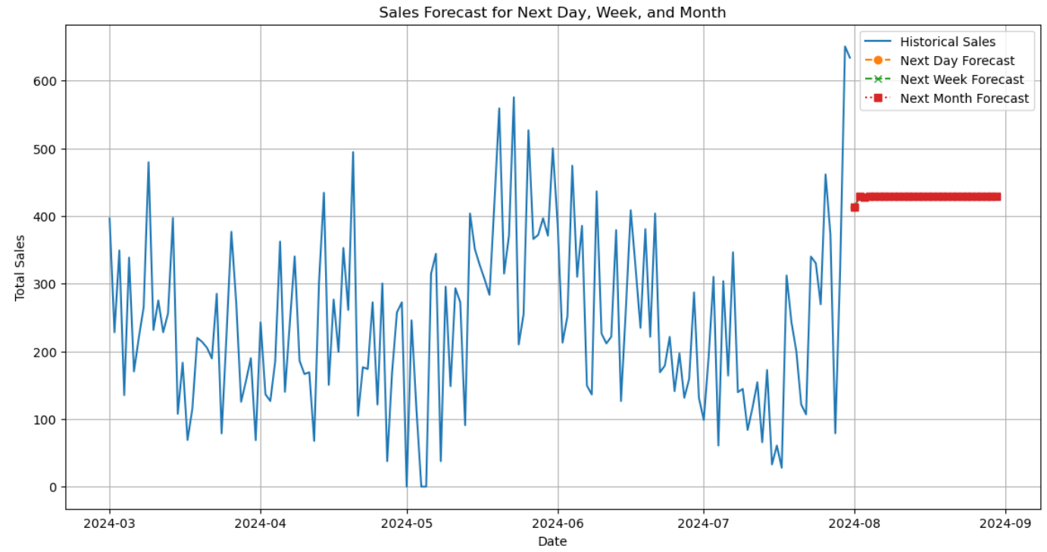

### **Sales Forecasts:**

1. **Next Day**:
   * Predicted Sales for the next day: **413.71**
2. **Next Week**:
   * Predicted Sales for the next 7 days:
     + 2024-08-01: 413.71
     + 2024-08-02: 429.49
     + 2024-08-03: 428.36
     + 2024-08-04: 428.44
     + 2024-08-05: 428.44
     + 2024-08-06: 428.44
     + 2024-08-07: 428.44
3. **Next Month**:
   * Predicted Sales for the next 30 days: The model indicates sales stabilizing around **428.44** from August 3rd onwards, suggesting a consistent sales trend for the month.

### **Insights:**

* **Stabilization**: The model forecasts a relatively stable sales trend after the initial few days, indicating that sales are expected to remain consistent throughout the month.
* **Short-Term Variations**: Minor fluctuations are present in the short-term forecast, possibly due to daily variations in demand.

| 413.7090825714696,  2024-08-01 413.709083  2024-08-02 429.494824  2024-08-03 428.362817  2024-08-04 428.443994  2024-08-05 428.438173  2024-08-06 428.438590  2024-08-07 428.438560  Freq: D, Name: predicted_mean, dtype: float64,  2024-08-01 413.709083  2024-08-02 429.494824  2024-08-03 428.362817  2024-08-04 428.443994  2024-08-05 428.438173  2024-08-06 428.438590  2024-08-07 428.438560  2024-08-08 428.438563  2024-08-09 428.438562  2024-08-10 428.438562  2024-08-11 428.438562  2024-08-12 428.438562  2024-08-13 428.438562  2024-08-14 428.438562  2024-08-15 428.438562  2024-08-16 428.438562  2024-08-17 428.438562  2024-08-18 428.438562  2024-08-19 428.438562  2024-08-20 428.438562  2024-08-21 428.438562  2024-08-22 428.438562  2024-08-23 428.438562  2024-08-24 428.438562  2024-08-25 428.438562  2024-08-26 428.438562  2024-08-27 428.438562  2024-08-28 428.438562  2024-08-29 428.438562  2024-08-30 428.438562  Freq: D, Name: predicted_mean, dtype: float64) |
| --- |

# 

# 

# Customer Purchasing Patterns Analysis

### **4.1 . Top Customers by Number of Transactions**

| # Top Customers by Number of Transactions top_customers = coffee_sales_data['card'].value_counts().head(10)  # Visualize the top customers plt.figure(figsize=(10, 5)) top_customers.plot(kind='bar') plt.title('Top 10 Customers by Number of Transactions') plt.xlabel('Customer ID') plt.ylabel('Number of Transactions') plt.show()  # Display top customers top_customers |
| --- |

**Result Visualization:**

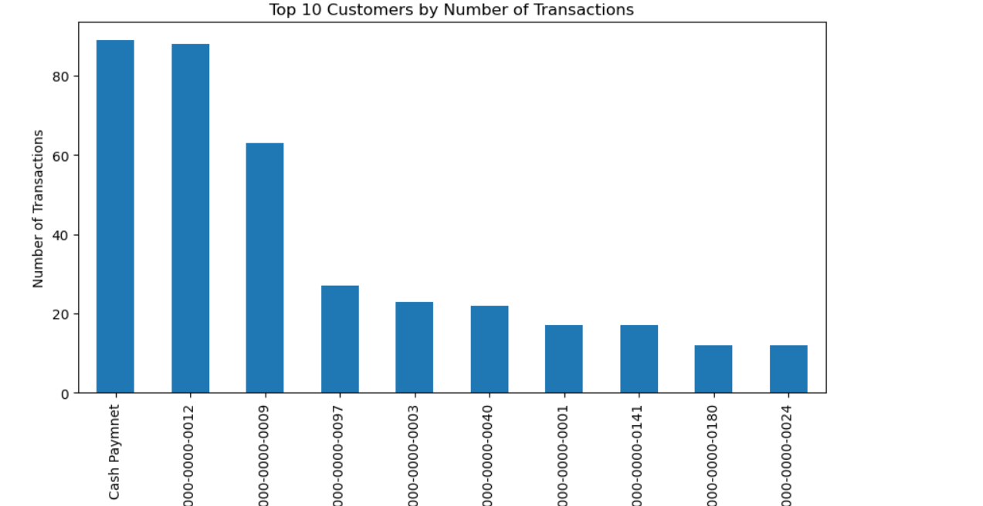

* The plot shows the top 10 customers based on the number of transactions.
* The most active customer (ANON-0000-0000-0012) has made 88 purchases, significantly more than others.

| Customers Summary card Cash Paymnet 89 ANON-0000-0000-0012 88 ANON-0000-0000-0009 63 ANON-0000-0000-0097 27 ANON-0000-0000-0003 23 ANON-0000-0000-0040 22 ANON-0000-0000-0001 17 ANON-0000-0000-0141 17 ANON-0000-0000-0180 12 ANON-0000-0000-0024 12 |
| --- |

### **4.2 Most Popular Coffee Type**

| # Popular Coffee Types popular_coffees = coffee_sales_data['coffee_name'].value_counts()  # Visualize the most popular coffee types plt.figure(figsize=(10, 5)) popular_coffees.plot(kind='bar', color='skyblue') plt.title('Most Popular Coffee Types') plt.xlabel('Coffee Name') plt.ylabel('Number of Purchases') plt.show()  # Display popular coffee types popular_coffees |
| --- |

Result Visulaization:

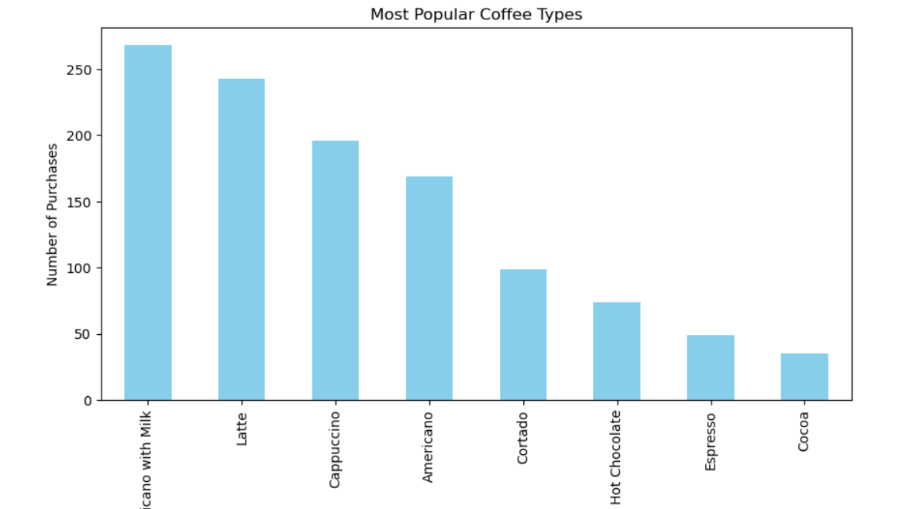

* The most frequently purchased coffee is "Americano with Milk" with 268 purchases.
* Other popular choices include "Latte" (243), "Cappuccino" (196), and "Americano" (169).

| Coffee Summary coffee_name Americano with Milk 268 Latte 243 Cappuccino 196 Americano 169 Cortado 99 Hot Chocolate 74 Espresso 49 Cocoa 35 |
| --- |

### **4.3 Preferred Coffe Type for Top Customer**

| # Exclude "Cash Payment" from the top customer analysis  valid_customers = coffee_sales_data[coffee_sales_data['card'] != 'Cash Payment']  # Analyze Purchasing Patterns for the Top Customer (excluding 'Cash Payment')  top_customer_id = valid_customers['card'].value_counts().index[0]  top_customer_purchases = valid_customers[valid_customers['card'] == top_customer_id]['coffee_name'].value_counts()  # Visualize the preferred coffee types for the top customer plt.figure(figsize=(10, 5)) top_customer_purchases.plot(kind='bar', color='orange') plt.title(f'Preferred Coffee Types for Top Customer ({top_customer_id})') plt.xlabel('Coffee Name') plt.ylabel('Number of Purchases') plt.show()  # Display preferred coffee types for the top customer  top_customer_purchases |
| --- |

**Result Visulaization:**

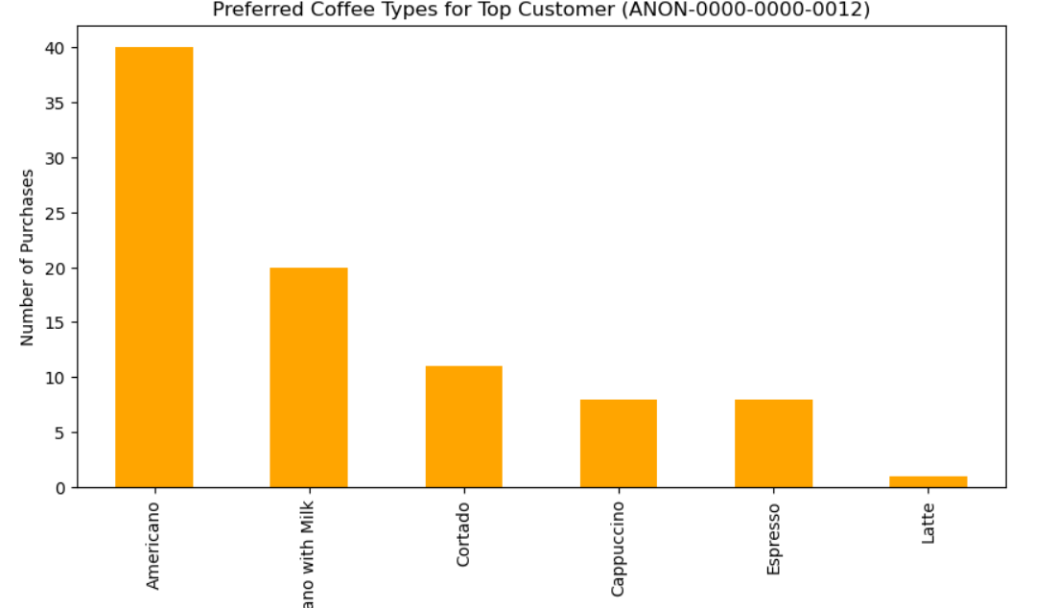

The top customer (ANON-0000-0000-0012) primarily prefers "Americano" (40 purchases) followed by "Americano with Milk" (20 purchases).

This customer also shows interest in "Cortado" and "Cappuccino."

| Summary coffee_name Americano 40 Americano with Milk 20 Cortado 11 Cappuccino 8 Espresso 8 Latte 1 |
| --- |

# Seasonal Sales Patterns

### **5.1 Weekly Seasonality Analysis**

### **5.2 Monthly Seasonality Analysis**

### **5.3 Order Days of the Week**

| # 1. Weekly Seasonality Analysis # Aggregate sales by day of the week coffee_sales_data['day_of_week'] = coffee_sales_data.index.day_name() weekly_sales = coffee_sales_data.groupby('day_of_week')['money'].sum()  # Order days of the week for visualization ordered_days = ['Monday', 'Tuesday', 'Wednesday', 'Thursday', 'Friday', 'Saturday', 'Sunday'] weekly_sales = weekly_sales.reindex(ordered_days)  # 2. Monthly Seasonality Analysis # Aggregate sales by day of the month coffee_sales_data['day_of_month'] = coffee_sales_data.index.day monthly_sales = coffee_sales_data.groupby('day_of_month')['money'].mean()  # 3. Visualizations for Seasonal Patterns fig, ax = plt.subplots(2, 1, figsize=(14, 10))  # Plot weekly sales pattern ax[0].bar(weekly_sales.index, weekly_sales) ax[0].set_title('Weekly Sales Pattern') ax[0].set_xlabel('Day of the Week') ax[0].set_ylabel('Total Sales') ax[0].grid(True)  # Plot monthly sales pattern ax[1].plot(monthly_sales.index, monthly_sales, marker='o') ax[1].set_title('Monthly Sales Pattern') ax[1].set_xlabel('Day of the Month') ax[1].set_ylabel('Average Sales') ax[1].grid(True)  plt.tight_layout() plt.show()  # Display the weekly and monthly sales data weekly_sales, monthly_sales |
| --- |

**Result Visulaization:**

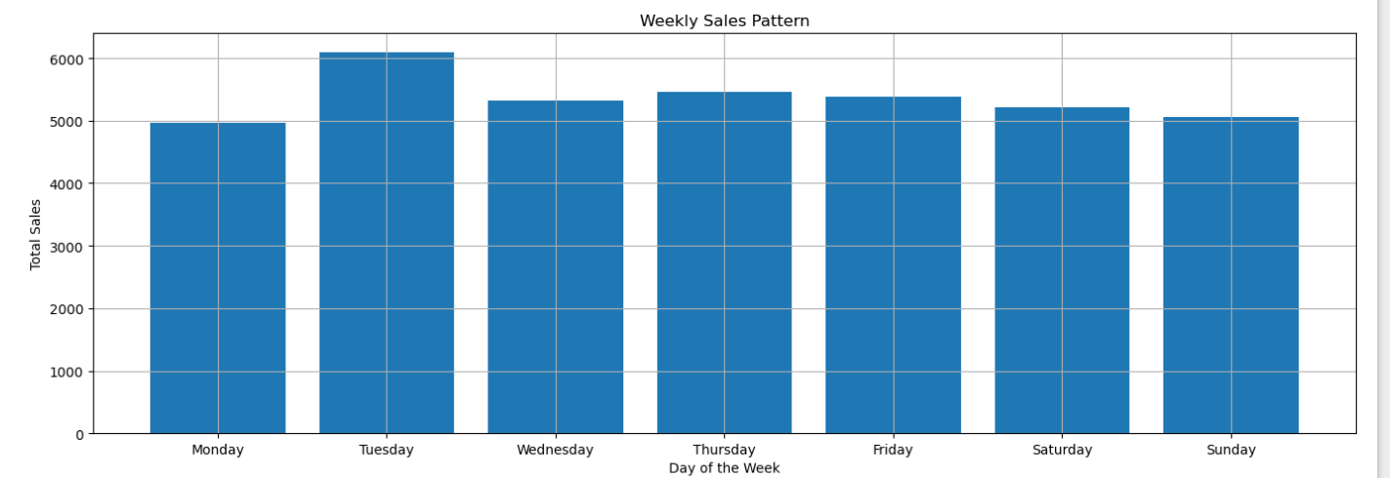

***The bar chart illustrates these trends, showing higher sales mid-week.***

**Weekly Seasonality:**

* **Trends by Day of the Week:**
  + Tuesday has the highest total sales (6,092.48), indicating it is a peak sales day.
  + Monday and Sunday have relatively lower sales, with Monday having the lowest total sales (4,969.68).
  + There is a noticeable mid-week peak in sales around Tuesday, with a slight decline towards the weekend.

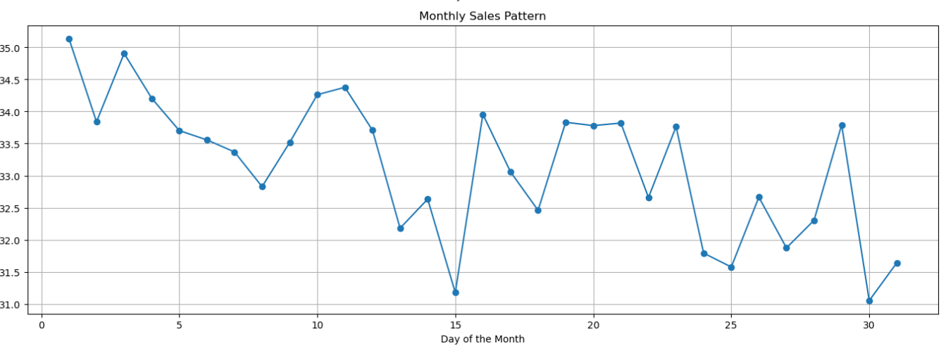

***The line chart shows the average sales per day of the month, indicating subtle monthly patterns.***

**Monthly Seasonality:**

* **Trends by Day of the Month:**
  + Sales show variability throughout the month, with some fluctuations but no pronounced peaks.
  + Days 1 to 5 tend to have slightly higher average sales compared to the middle and end of the month.
  + There is a small dip around the middle of the month (e.g., day 15) and a slight increase again towards the end.

### **Insights:**

* **Weekly Patterns:** There is a clear weekly seasonality, with sales peaking mid-week, especially on Tuesdays. This insight can help in planning promotions or staffing.
* **Monthly Patterns:** While the monthly patterns are less pronounced, there are subtle trends that suggest a slight increase in sales at the start and end of the month.

# Seasonal Products Trends

6.1 Weekly Products Trends

6.2 Monthly Product Trends

| # 1. Weekly Product Trends # Group sales by day of the week and coffee name weekly_product_sales = coffee_sales_data.groupby(['day_of_week', 'coffee_name'])['money'].sum().unstack()  # 2. Monthly Product Trends # Group sales by day of the month and coffee name monthly_product_sales = coffee_sales_data.groupby(['day_of_month', 'coffee_name'])['money'].mean().unstack()  # 3. Visualize the weekly product trends plt.figure(figsize=(14, 7)) weekly_product_sales.plot(kind='line', marker='o', figsize=(14, 7)) plt.title('Weekly Sales Trends by Coffee Type') plt.xlabel('Day of the Week') plt.ylabel('Total Sales') plt.xticks(rotation=45) plt.grid(True) plt.legend(title='Coffee Type', bbox_to_anchor=(1.05, 1), loc='upper left') plt.tight_layout() plt.show()  # 4. Visualize the monthly product trends plt.figure(figsize=(14, 7)) monthly_product_sales.plot(kind='line', marker='o', figsize=(14, 7)) plt.title('Monthly Sales Trends by Coffee Type') plt.xlabel('Day of the Month') plt.ylabel('Average Sales') plt.xticks(rotation=45) plt.grid(True) plt.legend(title='Coffee Type', bbox_to_anchor=(1.05, 1), loc='upper left') plt.tight_layout() plt.show()  # Display the first few rows of weekly and monthly sales data weekly_product_sales.head(), monthly_product_sales.head() |
| --- |

**Result Visulaization:**

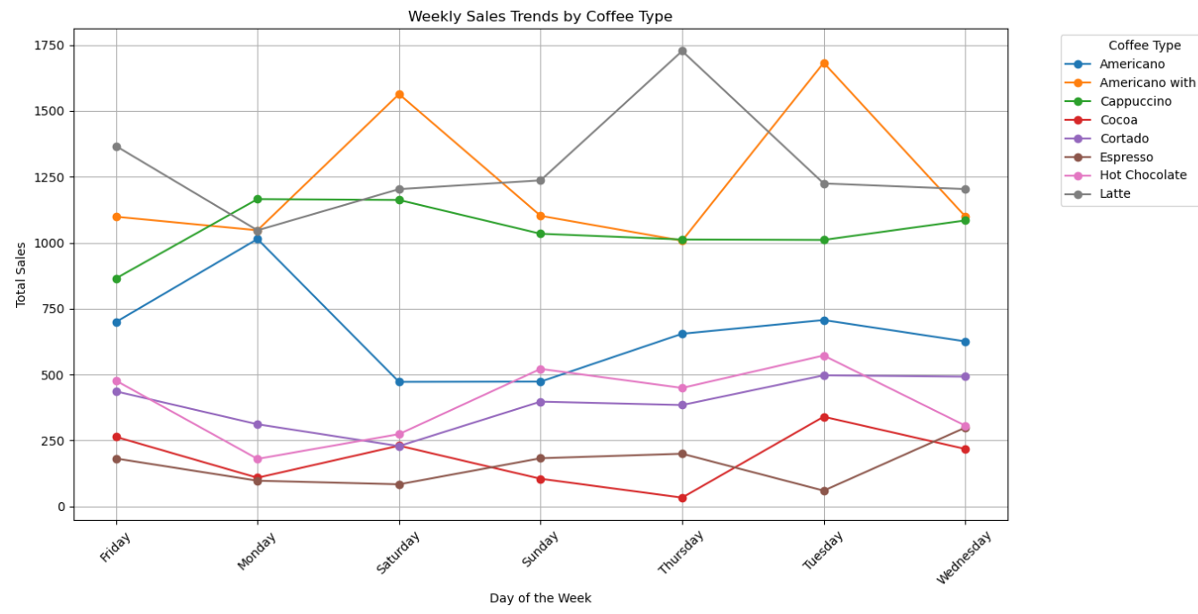

***The line plot illustrates these weekly patterns, showing how preferences for different coffee types fluctuate across the week*.**

**Weekly Product Trends:**

* **"**Americano with Milk" and "Latte" show consistently high sales throughout the week, with peaks on Saturdays and Fridays, respectively.
* "Cappuccino" sales are highest on Mondays, suggesting a strong start-of-the-week preference.
* "Hot Chocolate" sees increased sales on Sundays and Fridays, potentially indicating weekend indulgence.
* "Americano" has a balanced distribution, with noticeable peaks on Mondays.

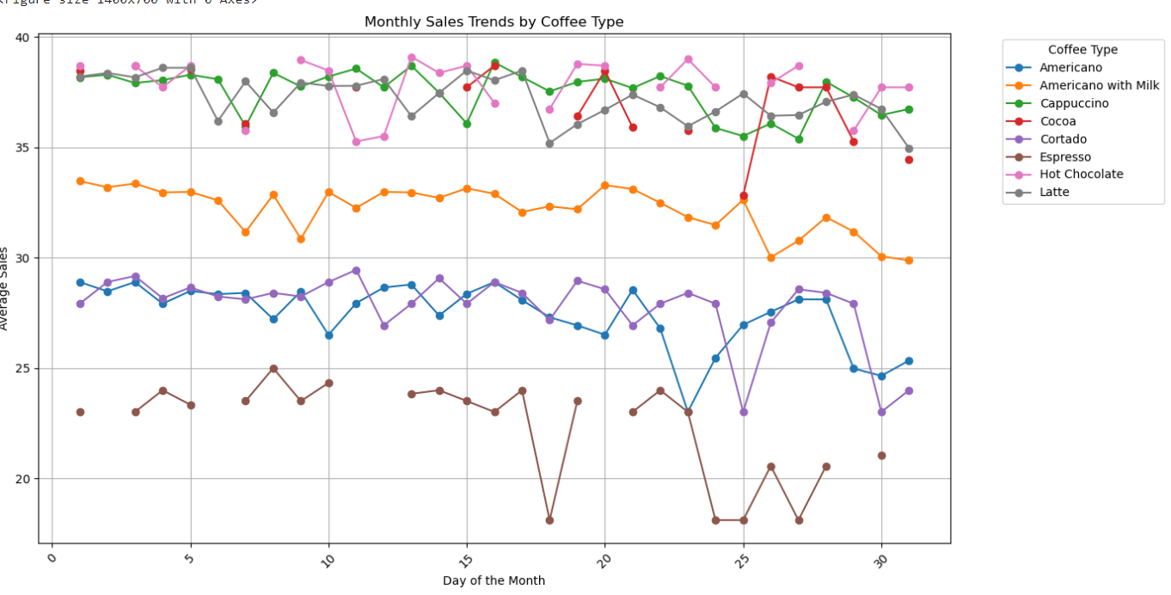

***The monthly trends plot reveals that while there are some variations, most coffee types have steady sales without pronounced monthly peaks.***

* Most coffee types, including "Latte," "Americano with Milk," and "Cappuccino," maintain relatively stable sales throughout the month.
* "Cocoa" shows some variability, with higher average sales at the beginning and potentially around mid-month.
* Other products like "Espresso" exhibit minor fluctuations but generally maintain consistent sales.

# Actionable Recommendations

### **Short-Term Actions:**

1. **Optimize Promotions:**
   * Run special promotions or discounts on low sales days (e.g., Mondays) to boost activity.
   * Highlight popular coffee types like "Americano with Milk" in marketing campaigns to attract customers**.**
2. **Leverage Customer Preferences:**
   * Use customer purchase patterns to tailor offers, such as targeted discounts on preferred coffee types.
   * Reward top customers with loyalty programs, personalized offers, or exclusive deals to maintain engagement.
3. **Stock and Staff Management:**
   * Align inventory and staffing with weekly sales patterns, ensuring adequate stock and staffing levels, particularly on peak days like Tuesdays.

### **Long-Term Actions:**

1. **Segment-Specific Strategies:**
   * Develop targeted marketing strategies for different customer segments, with premium offers for "High" and "Very High" spenders.
   * Introduce incentives or referral programs to encourage "Low" and "Medium" spenders to increase their purchases.
2. **Enhance Customer Experience:**
   * Use insights from purchasing patterns to create a personalized customer experience, such as customized coffee recommendations based on past purchases.
   * Implement a rewards system that encourages frequent purchases and increases customer loyalty**.**
3. **Seasonal Promotions:**
   * Plan seasonal promotions around identified sales patterns, such as end-of-month specials, to take advantage of the subtle increase in sales.

### **Future Analysis Suggestions:**

1. External Factors: Explore the impact of holidays, events, or promotions on sales trends to optimize future marketing efforts.
2. Cross-Sell Opportunities: Analyze additional data, such as side purchases (e.g., pastries), to identify cross-selling opportunities.
3. Customer Feedback: Incorporate customer feedback to refine product offerings and improve customer satisfaction.

# Conclusion

The comprehensive analysis of coffee sales data has provided valuable insights into sales trends, customer behavior, and seasonality. By implementing the actionable recommendations, the business can optimize its operations, enhance customer engagement, and drive revenue growth.